**2020/2021 Semester 2: 1104 Tutorial 8**

**Q1 Lay/Ch5.1/pg271/Ex6+7**

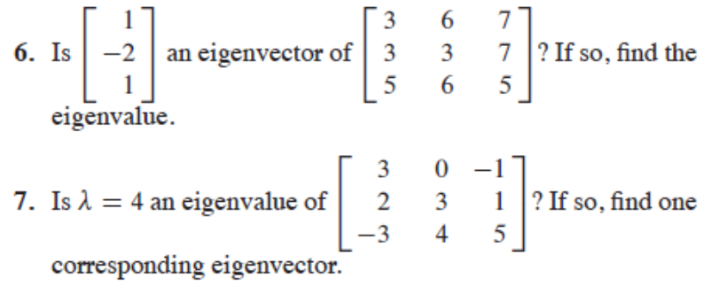

Sol:

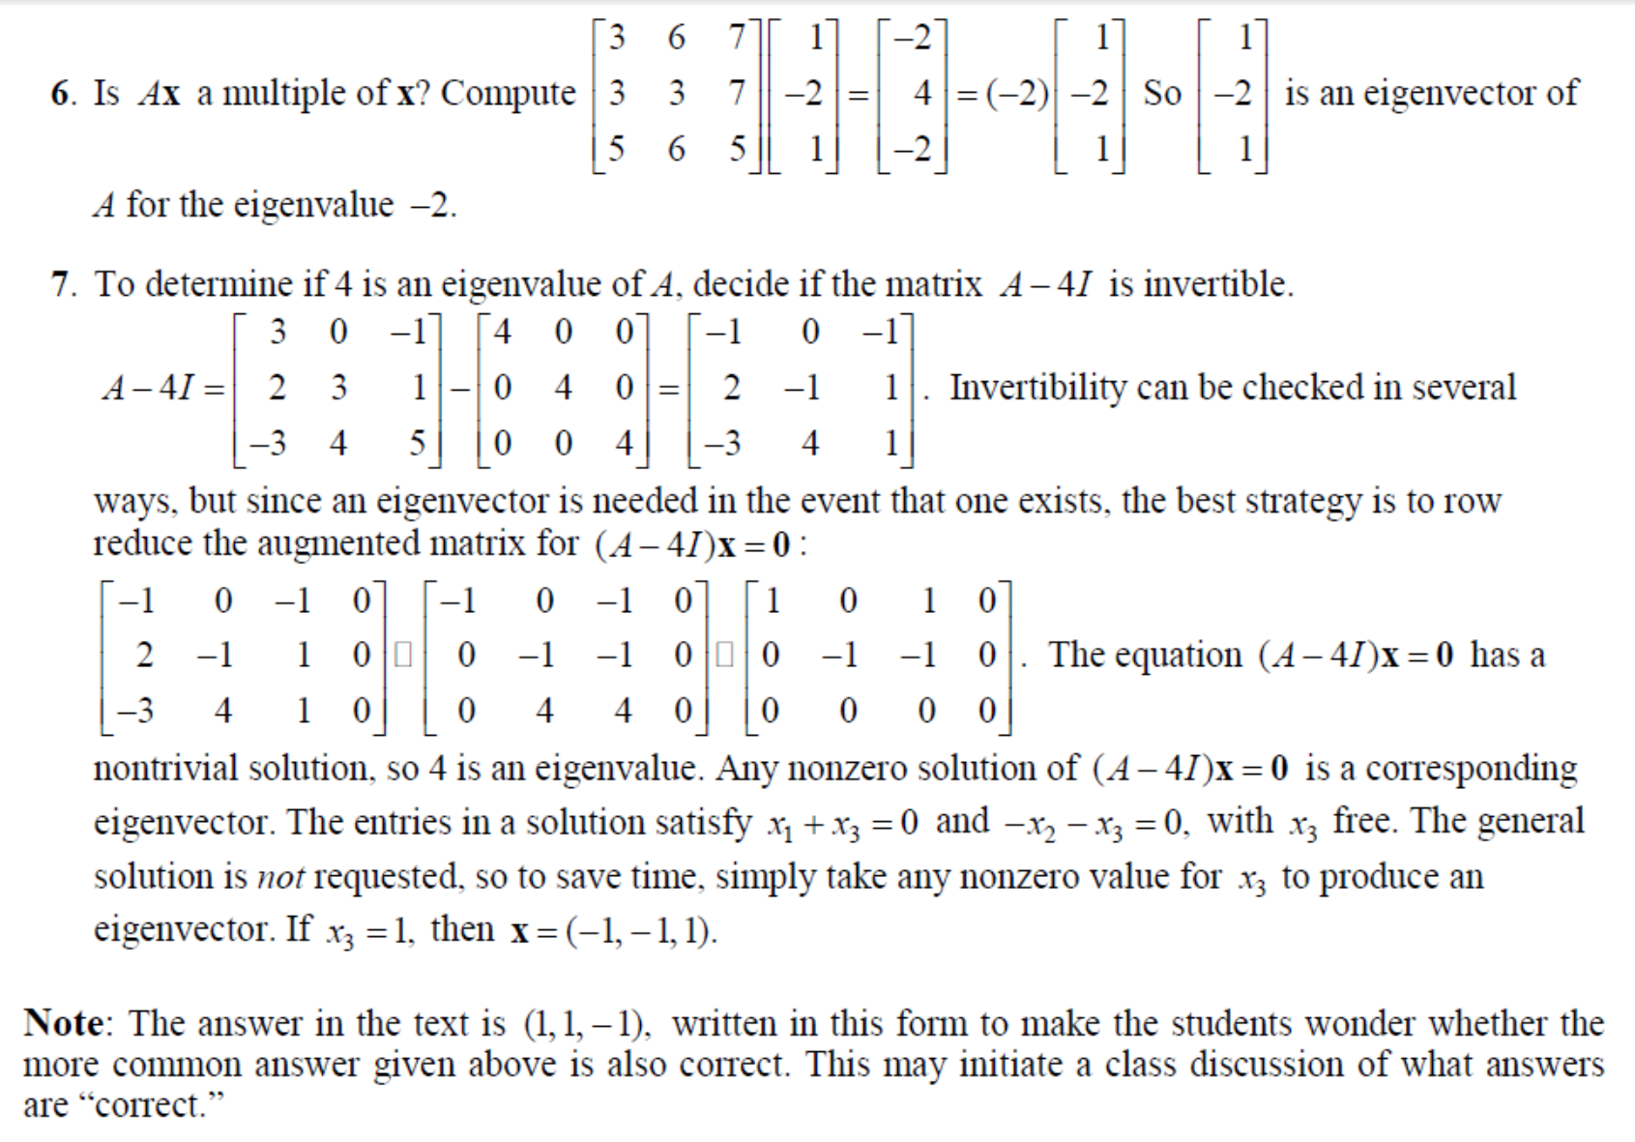

**Q2: Find the eigenvalues & eigenvectors of**



Solution:

­



Q3) Lay/Ch5/pg272/

**Find an eigen -basis of the -2 eigenspace of A.**

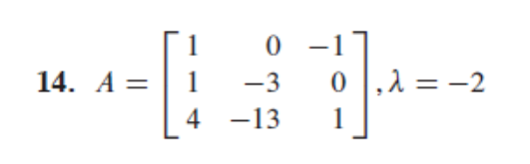

Ans: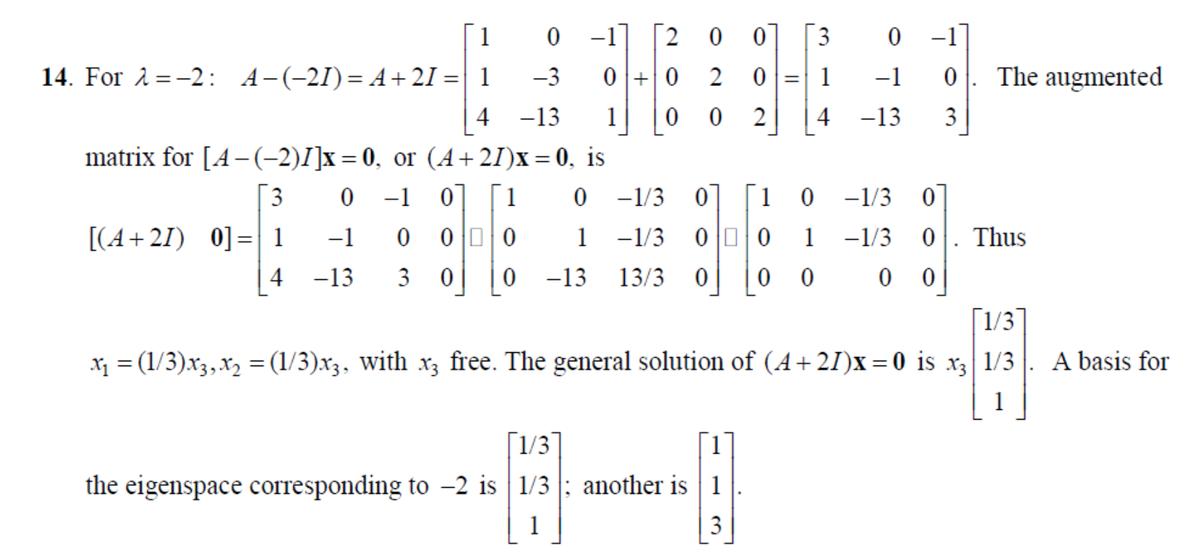

**Q4) Lay/Ch5/pg 274/Q20**

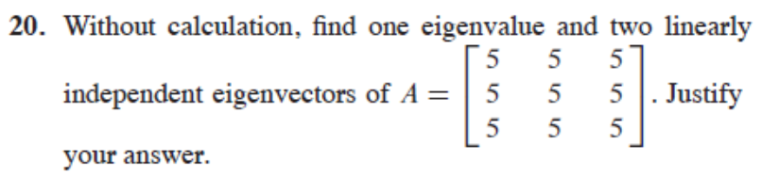

Sol:

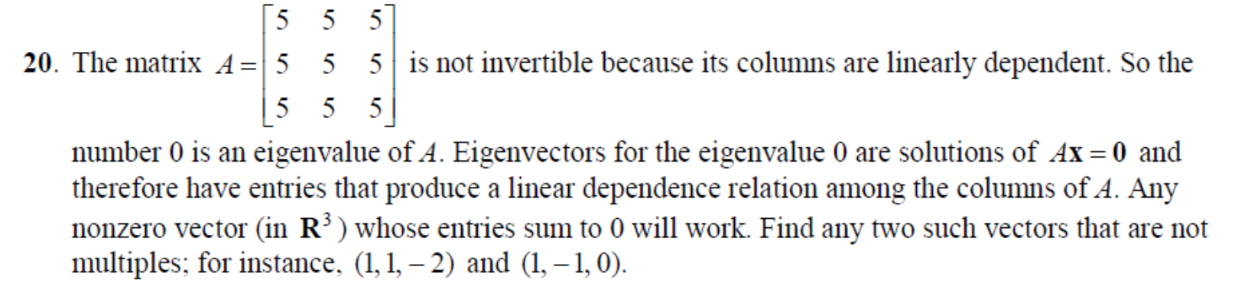

Note: **Ax=0 implies 5x + 5y + 5z = 0, so x +y + z = 0.**

**Q5: If {u,v} are linearly independent eigenvectors, then they must correspond to distinct eigenvalues.**

False. Example below-2 linearly independent eigenvectors, but with same eigenvalues!





**Q6) Lay/ch5.1/pg 274/Q5**

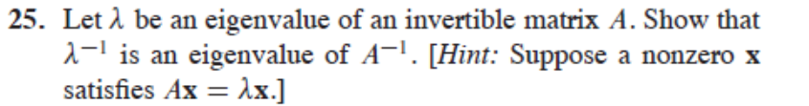

Sol:

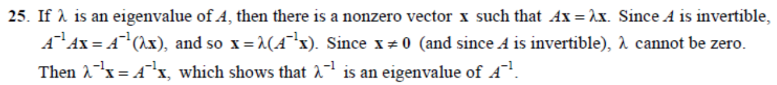

**Q7) Lay/Ch5.3/pg288**

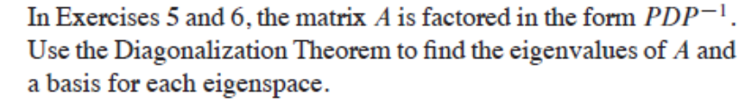

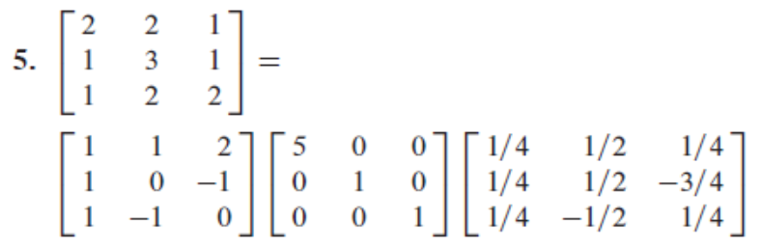

Sol:

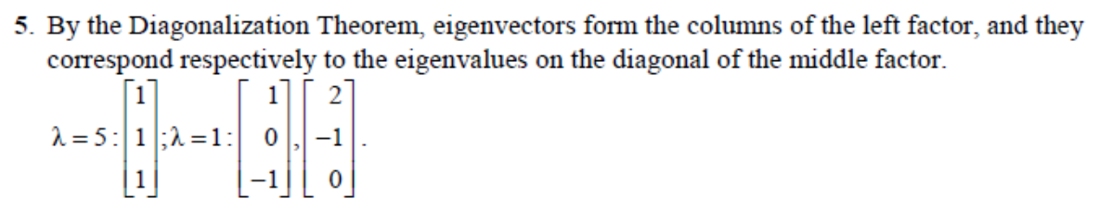

**Q8) Lay/Ch5.3/pg 289/Q21+23**

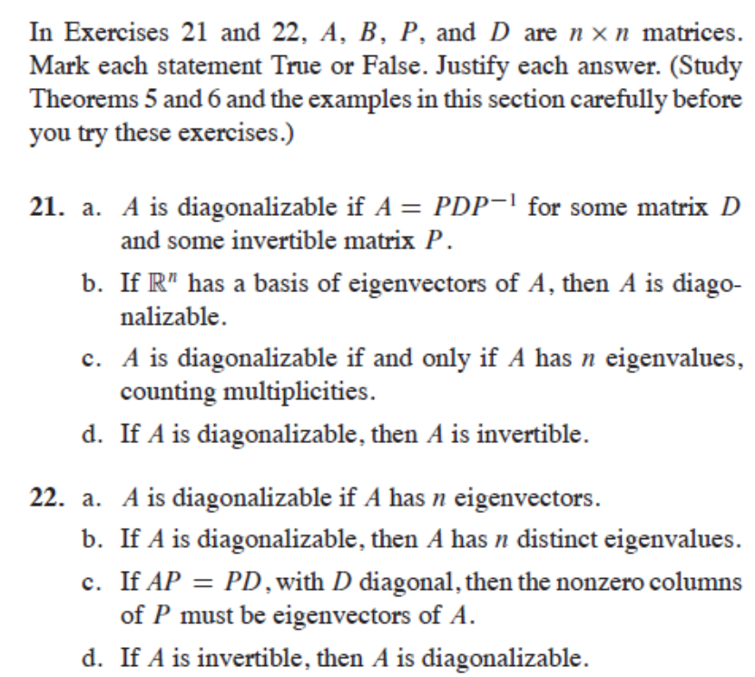

Sol:

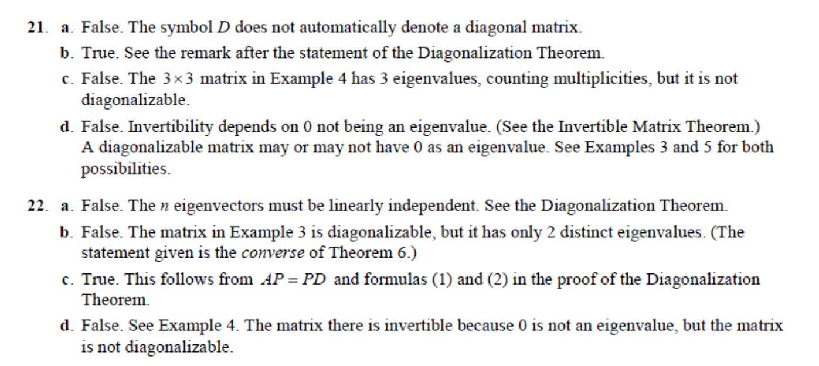

21c & 22d: Example 4:



Q9) Lay./Ch5.3/pg289/Q31+32

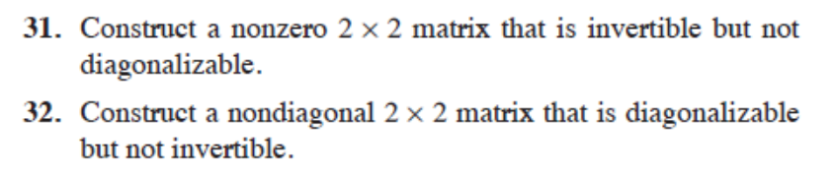

Sol:

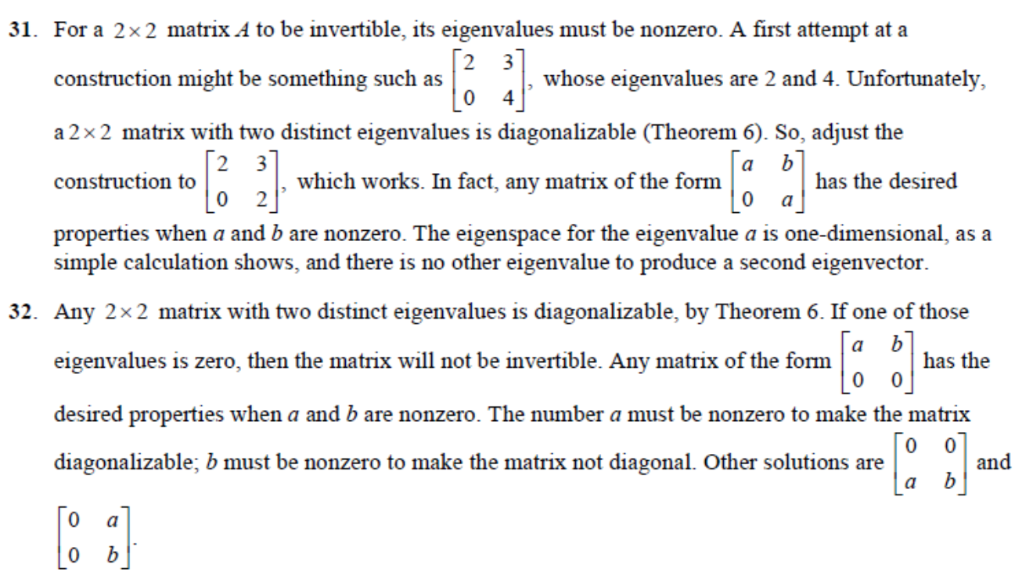

### Both a,b not 0!

Q10) Lay/ch5.6/pg 311/Practise

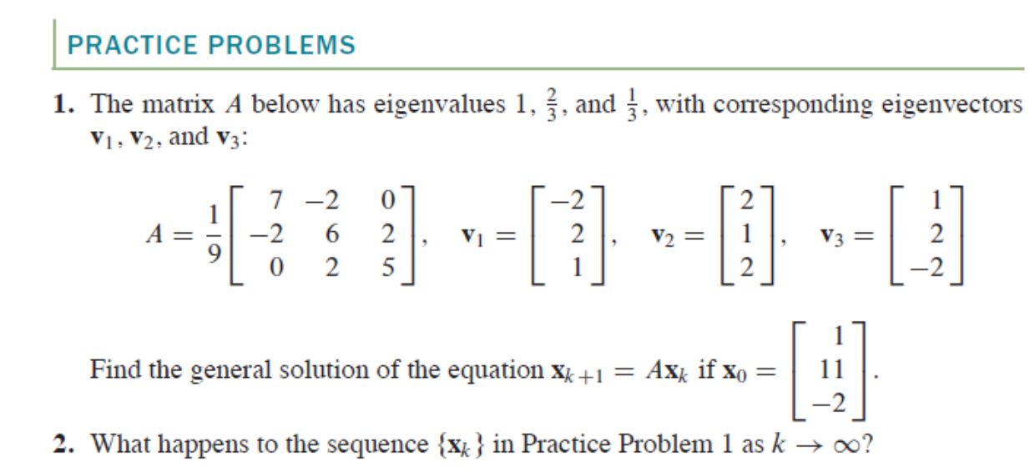

**Sol:**

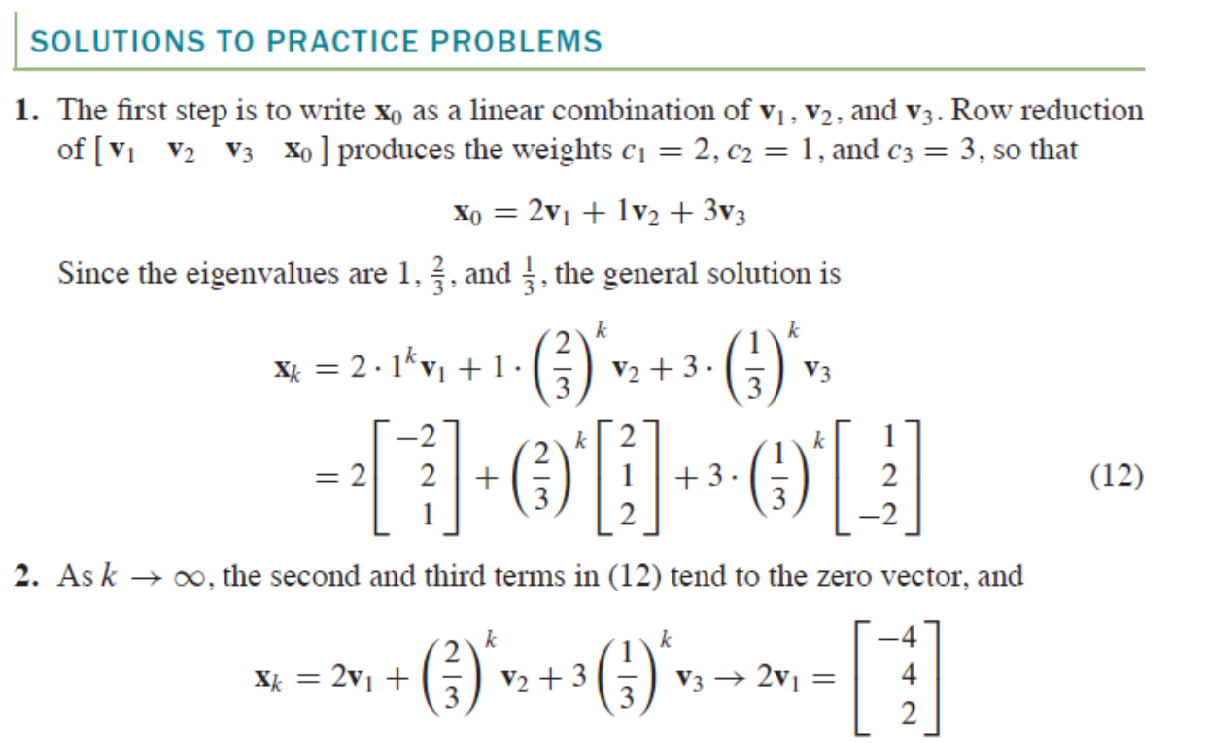

Q11:



**Solution:**

